Remembering the Holodomor
Notes for Discussion

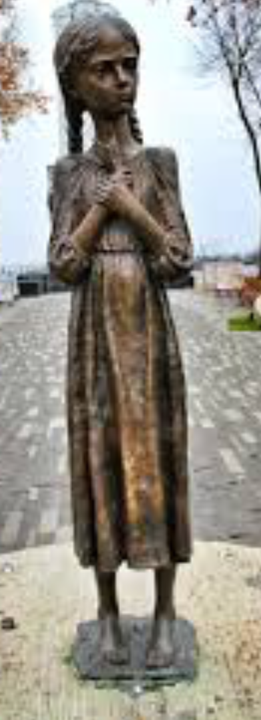
There is no doubt that the Holodomor is one of the most horrific genocides of the 20th century. We study these types of events to commemorate them in our memories but also to learn how we might recognize and avoid them in the future. Often, tragic events like this are commemorated with monuments like Bitter Memories of Childhood, which is on display at the Canadian Museum for Human Rights and Manitoba’s Legislative Grounds; both are replicas of the original work created for the National Museum “Holodomor Victims Memorial” in Kyiv, Ukraine’s capital city.

Facial expression - intended to depict sadness, helplessness, mourning

hair braids - representing peasant life style and poverty

blouse with Ukrainian embroidery - representing the nation of Ukraine where the Holodomor had its greatest impact

five stalks of grain - held in the girl’s hand, representing the Law of Five Grains which could result in even children being arrested or shot

emaciated body - representing the toll taken on the human body after long periods of malnutrition

bare feet - representing the destitute conditions survived by peasants living in poverty in Ukrainian villages

millstone - beneath the girl’s feet to represent the tool used to turn wheat kernels into flour used for bread

single figure - intended to portray the fact that some families were
decimated by the effects of Holodomor, leaving single survivors in some cases

Remembering the Holodomor
Name:________
Date:_________
Class:_________

There is no doubt that the Holodomor is one of the most horrific genocides of the 20th century. We study these types of events to commemorate them in our memories but also to learn how we might recognize and avoid them in the future. Often, tragic events like this are commemorated with monuments like Bitter Memories of Childhood, which is on display at the Canadian Museum for Human Rights and Manitoba’s Legislative Grounds, both replicas of the original work created for the History of National Holodomor Victims Memorial Museum in Kyiv, Ukraine’s capital city.

Remembering the Holodomor
Name:________
Date:_________
Class:_________

In the space provided below: 1. List the main issues and themes that the Holodomor teaches. 2. What are the most important lessons? 3. Why should we learn about genocides? 4. How does it benefit us today to learn about the past?

Remembering the Holodomor
Name:________
Date:_________
Class:_________

In the space below, design a monument to represent the Holodomor.
In your monument:
1. Identify five elements that are dedicated to a specific aspect of this genocide, as were identified in the Bitter Memories of Childhood monument. These elements could be symbols, the materials used, shapes, colours or single words, letters or numbers, phrases, or other.
2. Provide a brief description of your rationale for choosing your elements.

