Three Issues to Examine on the Holodomor (High School Edition)

Author: Thomas R. Mueller, Ph.D., GISP (California University of Pennsylvania, Geography Professor) and Educational Associate for Harvard University’s Ukrainian Research Institute’s MAPA (Digital Atlas of Ukraine) program, with William Greene (California University of Pennsylvania, student).
Grade Level: College Freshmen and Senior High School Grades 11 – 12

Time Frame: 3 – 45 minute periods

National Geography Standards:
Standard 1: How to use maps and other geographic representations, geospatial technologies, and spatial thinking to understand and communicate information

Standard 13: How the forces of cooperation and conflict among people influence the division and control of Earth's surface

Materials Required: Computers, Wi-Fi access, printer and PowerPoint

Objectives

After this assignment, students should be able to:

Analyze historical data and draw conclusions

Analyze maps to examine spatial patterns (i.e.: Are the higher and/or lower values in a particular part of Ukraine? etc.)

Background:
The Holodomor, which means “death by forced starvation” in Ukrainian, refers to starvation of millions of Ukrainians from 1932-33. Students will examine 1 of 3 issues in groups.
- Collectivization
- Losses by Nationalities
- Environmental issues

Lecture Before Exercise
Before the exercise, the teacher may want to give a PowerPoint presentation or show a film on the collectivization process (generally) under Stalin.
Also, the teacher should explain the difference between oblasts and raions.

Activities:
- Go to the website, copy and paste the link http://gis.huri.harvard.edu/
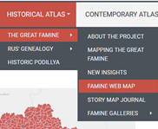

Go to Historical Atlas on the drop-down menu and select “The Great Famine” and then “Famine Web Map.” Then click on “View the Famine Web Map” and click on “OK”.

Divide the class into 3 equal groups:

Environmental

Collectivization

Nationalities

Each group will construct maps and charts on a topic in the Great Famine. After creating their maps the groups will compare them with the Direct Losses Maps. Each group will further research their topic and present it to the class.

ACTIVITY: – All groups should create these maps
- Under “Population Losses, 1932 - 34”, click the Dropdown Menu arrow and put a check in the box next to the layer titled: “Direct Famine Losses by Region in 1932, per 1000”
- Describe the locational area most impacted based on population losses
- Click the More Icon located above the Layer list
- Choose Print
- Map Title – Put a Proper Title
- Layout – Letter ANSI A Landscape (May need to choose this one first)
- Format – JPG
- Click Print
- There will be a link provided. Click the Link and either Print the map or Save the Image to be added to PowerPoint
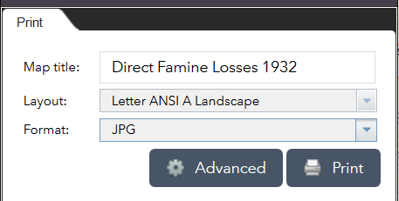
- Click Layer List
- Now uncheck 1932 per 1000 and repeat Step 2 – 8 for the following layers:
  - 1933
  - 1934

Collectivization Group:
- Select the map layer titled “Collectivization, 1932-1936”, by clicking the drop down menu
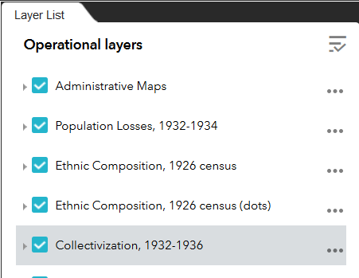
- Then check the first box from the drop down menu titled, “Collectivized households in 1932, %”
- Examine the data displayed from this layer and be sure to uncheck the layer when finished.
- Describe the locational area most collectivized
- Why do you think the percent of collectivization was different in certain areas?
- Now compare Direct Famine Losses with the Collectivization Losses
- Describe the locational patterns of Collectivization and compare it to the Population Losses.
- Complete research on Collectivization in Ukraine and create a presentation with your maps. Students then create a hypothesis on possible spatial patterns comparing collectivization and the population losses. (Why was collectivization relatively higher in certain areas and not in others? etc. )

Losses by Nationalities Group:
- Click the “Population Losses” drop down menu and choose the layer titled – “Total Losses by Nationalities 1933 per 1000 of ethnic group; oblast chart”
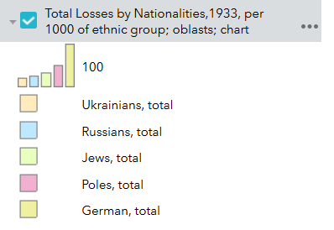
- In which areas were the number of Ukrainian losses highest?
- Now compare Direct Famine Losses with the Losses by Nationalities
- Describe the locational patterns of Nationalities and compare it to the Population Losses.
- Complete research on Ukrainian nationality losses under Stalin and create a presentation with your maps. Students then create a hypothesis on possible spatial patterns comparing nationality and population losses.

Environmental Group

The Famines of the 1920’s #2 and #3
- Click The Famines of the 1920s, expand the list of layers. It can be expanded by clicking a single time the small right facing triangle to the left of the layers title.
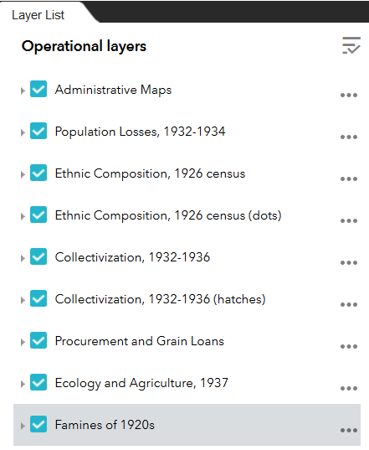
- Once you expand the heading, 3 map layers should then appear with an empty check box next to each of them.

- First, select the 2nd box titled; “Famine Intensity in Ukraine, April 1922. Famine stricken rural population %”. Once the box is checked you can examine the data and observe the differences between certain oblasts and raions of Ukraine.

  - Describe the locational area most impacted by the Famine of the 1920s.
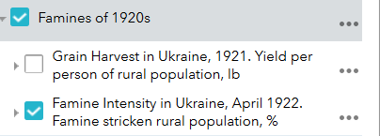

- After you are done observing that map layer
- Un-check the box next to it to turn the layer back off.
- Next, check the box next to the third of the layers titled, “Officially Declared Disaster Areas in Ukraine, 1928-1929”.

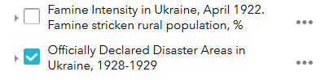
- Examine the spatial patterns.
- Describe the locational area most impacted by the 1928 – 1929 famine.
- Print the Map
- Now compare Direct Famine Losses of the 1922 and 1928-29 Famine Maps
    - Similar Patterns?
    - Location of Higher losses?

Ecology and Agriculture Maps
- Uncheck the last map and Click Ecology and Agriculture, 1937
- Put a check in the Ecological Zones of Ukraine by Kubijovyc, 1937
- Describe the location patterns of:
  - Dry maritime steppe
  - Dry northern steppe
  - Boreal forest steppe
  - Boreal mixed forest
- Compare this map to the Population Losses Maps
- Now Print this map
- After unchecking the Ecological Zones Map, please put a check in Wheat Growing Areas, 1937, percent
- Describe the locational patterns and compare this map to the Population Losses.
- Complete research on the following and create a presentation with your maps. Students then create a hypothesis on possible spatial patterns comparing environmental factors including past famines and the population losses.
- 1922 and 1928-29 famines (Compared to Population Losses 1932 – 34)
- The ecological zones (Compared to Population Losses 1932 – 34)
In which zone did people have a better chance of surviving? Why?
- Which are the main grain producing areas in Ukraine (Compare them to Population Losses 1932 – 34)

Class Discussion
Students present their analysis of the maps and research.
- Each group should present their findings to the class.
- Each group presents their findings to the class using the maps, charts and research.
- As a class, answer the following question: What was the cause(s) of the Great Famine?
- With the help of students, the teachers create a summary of the Great Famine.
- A follow-up assignment is recommended. See websites for suggestions:
      - Holodomor Research and Education Consortium - http://education.holodomor.ca/teaching-materials/
      - Connecticut Holodomor Awareness Committee - http://holodomorct.org/holodomor-information-links/holodomor-classroom-resources-teachers/

References

Plokhii, Serhii Mapping the Great Famine, http://gis.huri.harvard.edu/historical-atlas/the-great-famine/mapping-the-great-famine.html

Holodomor Research and Education Consortium (HREC), https://education.holodomor.ca/, https://holodomor.ca/

